financial health Check

ระบบเช็คสุขภาพทางการเงินส่วนบุคคลผ่าน Line liff

BY

mr. Chatchai kraisornsin 6288086

ADVISOR

Asst. prof. dr. Srisupa palakvangsa na ayudhya

A Senior Project Submitted in Partial Fulfillment of

the Requirements for

THE DEGREE OF BACHELOR OF SCIENCE

(INFORMATION AND COMMUNICATION TECHNOLOGY)

Faculty of Information and Communication Technology

Mahidol University

2022

**COPYRIGHT OF MAHIDOL UNIVERSITY**

**Acknowledgement**

I would like to express my sincere appreciation to all those who have supported me in completing my senior project.

Firstly, I would like to extend my gratitude to Asst. Prof. Dr. Sudsanguan Ngamsuriyaroj and Dr. Arinchaya Threekunprapa for their invaluable guidance and advice throughout my project. Their expertise and insights on the topic of financial literacy have been instrumental in helping me navigate the project's complexities.

Additionally, I would like to thank my colleagues, classmates, and friends who have provided me with constructive feedback and support throughout the project. Their encouragement and contributions have been invaluable to my success.

I also would like to acknowledge the organization or college where my senior project was performed for giving me the resources and tools that I needed to successfully complete this assignment.

Lastly, I would like to express my deep appreciation to my family for their unwavering support and encouragement throughout my academic journey. Their constant support and encouragement have been a source of inspiration and motivation for me.

Thank you all for your support and contributions towards the completion of my senior project. I am immensely grateful for your guidance and encouragement throughout this journey.

Mr. chatchai Kraisornsin

FINANCIAL HEALTH CHECK system

mr. chatchai kraisornsin 6288086 ITCS/B

B.Sc. (INFORMATION AND COMMUNICATION TECHNOLOGY)

PROJECT ADVISOR: asst. prof. dr. srisupa na ayudhya

ABSTRACT

In today’s era, one of the skills needed to live a life of properity for all ages. That’s financial literacy skills. Financial skills include knowledge, behavior and financial attitude. Which is an important factor in financial management. Thai people are uncertain in allocating their savings. They were at 40.6 percent and were not interested in saving at 5.7 percent, with only 19.7 percent having a share of savings before spending money, in addition, some have more money savings. But without the knowledge that do not know to grow to create value and to generate Muti-income.

Considering the cause of such problems, it is found that these problems are caused by management and financial planning. Effective is not enough, however, these problems it is something that can track one’s financial behavior can prevent and develop having good management before retirement will create a new conceptual framework to be able to create effective financial health with the support of personal financial advisors who gradually give advice to manage your finances to have financial freedom

For this reason, the developers have introduced a system celled Personalized financial advisor as one of the tools for everyone to assess and rate their financial health at all levels along with giving advice on managing personal finances including setting the goals in each plans for collecting money in each period For this reason, the developers have introduced a system called Personalized financial advisor as one of the tools for everyone to assess and rate their financial health at all levels. along with giving advice on managing personal finances including setting goals in various financial plans For collecting money in each period, in addition, " Personalized financial advisor " also has special features. Developed after the 6 Jars theory, 9 Jars and suggeswtion will help you manage your finances more efficiently. and is more clear as well

KEYWORDS : Financial literacy / LINe liff / money management / financial freedom / suggetion / 6 jars

P.

โครงการระบบประเมินสุขภาพทางการเงินส่วนบุคคลผ่านไลน์สำหรับบุคคลทั่วไป

นาย ชัชชัย ไกรสรสินธุ์ 6288086 ITCS/B

วท.บ. (เทคโนโลยีสารสนเทศและการสื่อสาร)

อาจารย์ที่ปรึกษาโครงการ: ผู้ช่วยศาสตราจารย์ ดร. ศรีสุภา ปาลกะวงศ์ ณ อยุธยา

บทคัดย่อ

ในยุคปัจจุบันหนึ่งในทักษะที่จำเป็นในการใช้ชีวิตอย่างอุดมสุขของทุกๆช่วงวัย นั่นคือทักษะความรู้ทางการเงิน โดยทักษะทางการเงินจะประกอบไปด้วย ความรู้ พฤติกรรม และทัศนคติทางการเงิน ที่เป็นปัจจัยสำคัญในการบริหารการเงิน อย่างไรก็ตาม พฤติกรรมการจัดสรรเงินออม คนไทยมีความไม่แน่นอนในการจัดสรรเงินออม อยู่ที่ร้อยละ 40.6 และไม่สนใจเรื่องการออมเงินอยู่ที่ร้อยละ 5.7 โดยมีเพียงร้อยละ 19.7 ที่มีการแบ่งส่วน ของเงินออมไว้ก่อนที่จะนำเงินไปจับจ่ายใช้สอย การตัดสินใจซื้อสิ่งต่างๆ โดยน้อยที่จะมีการเปรียบเทียบข้อมูลข้อมูลผลิตภัณฑ์ก่อนจะใช้จ่ายเงิน และ บางคนมีเงินเก็บเงินออม แต่ไม่มีความรู้มีเงินไม่รู้จะทำอย่างไรให้งอกเงย เพื่อสร้างคุณค่าและเป็นรายได้หลายๆทาง

พิจารณาถึงสาเหตุของปัญหาดังกล่าวจะพบว่าปัญหาต่างๆเหล่านี้ เกิดจากการ บริหาร และวางแผนการเงิน ที่มีประสิทธิภาพ ไม่เพียงพอ อย่างไรก็ตามปัญหาเหล่านี้ เป็นสิ่งที่สามารถติดตามพฤติกรรมทางการเงินของตนเอง ป้องกันและพัฒนาได้ การมีการบริหารการจัดการเงินที่ดีก่อนวัยเกษียณ จะสร้างกรอบความคิดใหม่ ที่จะสามารถสร้างสุขภาพทางการเงินให้มีประสิทธิภาพ โดยมีการสนับสนุนจากที่ปรึกษาการเงินส่วนบุคคลที่ค่อยให้คำแนะนำให้การบริหารการเงินให้มีอิสรภาพทางการเงินที่ดีนั่นเอง

ไว้เหตุนี้คณะผู้พัฒนาจึงนำเสนอระบบเช็คสุขภาพการเงินส่วนบุคคล เพื่อเป็นหนึ่งในเครื่องมือสำหรับทุกคนในการประเมินและการให้คะแนนสุขภาพทางการเงินในทุกๆระดับ พร้อมกับการให้คำแนะนำในการบริหารจัดการการเงินส่วนบุคคล รวมถึงการตั้งเป้าหมายในแผนการเงินรูปแบบต่างๆ สำหรับสะสมเงินในแต่ละช่วงเวลา นอกจากนี้ยังมีฟีเจอร์พิเศษ ที่ถูกพัฒนาต่อจากทฤษฎี 6 Jars นั่นคือ 9 Jars ที่จะช่วยให้คุณจัดสรรการเงินได้อย่างมีประสิทธิภาพมากกว่า และมีความชัดเจนกว่าอีกด้วย

40 หน้า

**CONTENTS**

ACKNOWLEDGEMENTS **Error! Bookmark not defined.**

ABSTRACT iii

LIST OF TABLES ix

LIST OF FIGURES x

1. Introduction 1

1.1 Motivation 1

1.2 Problem Statement 2

1.3 Objectives of the Project 2

1.4 Scope of the Project 3

1.5 Expected Benefits 3

1.6 Organization of the Document 3

1. Background 4

2.1 Overview of the financial literacy **Error! Bookmark not defined.**4

2.2 MONEY INDEX……………………………………………………….5

2.3 SIX JARS SAVING METHOD………………………………………..6

2.4 PERSONAL FINANCIAL MANAGEMENT…………………………8

2.5 OVERVIEW OF COMPETITORS…………………………………….9

2.6 COMPETITOR ANALYSIS………………………………………….12

2.7 OVERVIEW OF THE TOOL AND TECHNOLOGIES……………..13

2.8 TERMINOLOGIES…………………………………………………..14

1. Analysis and Design 16

3.1 Solution design 16

3.2 FUTURE WORK 20

1. implementation 16

3.1 hardware and software requirement 16

3.1.1 requirement 20

1. Testing and evaluation 16

3.1 unit test 16

3.2 Gathering requirements 20

3.3 UER TESTING AND EVALUATION RESULT………………………..20

1. conclusion 16

3.1 Benefits 16

3.2 Problem and limitations 20

3.3 FUTURE WORK

LIST OF TABLES

Table 2.1 Competitor analysis features……………………………………….12

LIST OF FIGURES

Figure 2.1 Good financial health………………………………………………………5

Figure 2.2 Ratio of Money Index……………………………………………………...5

Figure 2.3 Six Jars saving technique…………………………………………………..7

Figure 2.4 Personal financial advisor application……………………………………10

Figure 2.5 Planme program interface…………………………………………………11

Figure 2.6 Lumpsum application interface…………………………………………...11

Figure 2.7 Line LIFF…………………………………………………………………13

Figure 2.8 Line ChatBot……………………………………………………………...13

Figure 3.1 Overview of Personalized Financial Advisor System…………………….16

Figure 3.2 Overview of Personalized Financial Advisor System (2)…………………17

Figure 3.3 Overview of Personalized Financial Advisor System (3)…………………17

Figure 3.4 Input to Money Index……………………………………………………..18

Figure 3.5 Sugguestions of each level………………………………………………..19

Figure 3.6 Ratio of 8 Jars money management………………………………………19

# CHAPTER 1

Introduction

This chapter mainly focuses on our project motivation, problems, objectives, scope, expected benefits, and the organization of the document. This topic is describing the inspiration and importance of this project to solve current problems.

## Motivation

Financial literacy covers more than simply accounting and money. it goes well beyond that in its meaning.its means knowledge and understanding of matters related to finance as well as having management skills. Financial literate people are Having the capacity to use their knowledge to manage money wisely for ongoing financial security and well-being Understanding the fundamentals of money management, such as earning, spending, saving, and investing, requires this crucial knowledge skill. It is a crucial ability for effective personal money management. Additionally, it can be used in calculations to collect funds for a long retirement with financial stability.

While financial awareness is crucial The Thai people have developed their financial literacy over time. However, it was discovered that Thai people lacked knowledge and expertise in managing money to prevent running out of money. and setting aside funds before usage Therefore, individual financial counseling Therefore, offering financial advice is another service. to possess sufficient understanding of investing or saving to generate additional revenue However, due to the current crop of financial advisors on the market, few people really use one. The majority of them engage in the buying and selling of insurance, which generates revenue by selling insurance policies related to taxes or inheritance.

We are inspired to build a platform for providing personal money management advisory services because of this. to have financial independence Avoid the issue of having insufficient cash and allocating money before it is used wisely.

## Problem Statement

The management or planning of one's finances is a highly common issue, particularly among Thai people. The financially risky practice of distributing funds before use Information comparison before buying The issue of not having enough money, which may result in consequences like having a negative financial status or debt, not having enough money, or spending money without carefully considering its use, if the allocation of money in this area is not good.

In view of this, Podduang is a technology that enables anyone to serve as a personal financial counselor. along with guidelines for maintaining excellent financial health as you work toward financial freedom helping you throughout your life to take care of yourself like a true financial advisor.

## Objectives of the Project

Project objectives include:

* To evaluate your financial situation.
* To enable online tools to provide access to personal financial health check.
* To comprehend and be able to use personal financial planning effectively.
* To monitor our financial status, and determine if it is good or poor, what has to be changed or fixed, how it fits with our financial objectives and improves our personal objectives.

## Scope of the Project

Personalized Financial Advisor was developed with the following scope:

* The scope of the project is to use Line LiFF technology to help users realize and manage their personal finances through a single platform online web service.
* To develop system to evaluate the user’s financial health status by grading by Money Index from 4 keys indicators.
* Content that has led the development of the project Taken from the book Money 101: Starting to count one towards a rich financial life.

## Expected Benefits

After completing this research, the expected benefits are as follows. The users will receive the benefits as follows.

* Users can get good money planning advice.
* Develop various financial skills
* Users reach their financial life goals in the way they hope.
* Successful users are personal finance. financially responsible financial literacy and have financial discipline

## Organization of the Document

This document consists of 6 chapters including:

1. Introduction – Chapter 1: Introduction consists of 6 parts, including project motivation, statement issue, objectives, project scope. expected benefits and organization of documents.
2. Background – Chapter 2: Background describes the background and related work of the project.
3. Analysis and Design – Chapter 3: Analysis and Design Describe the project process. The system architecture method is represented by diagrams. Solution design, System structure chart, Data flow diagram, database design, and I/O design.

CHAPTER 2

# Background

This Chapter presents the overview of Financial Literacy and related method for grading

## Overview of the Financial literacy

Financial literacy refers to the capacity to understand and use various financial disciplines, such as personal financial management, budgeting, and saving, efficiently. In order to achieve financial security, people must become self-sufficient according to financial literacy.

Basic financial management skill includes:

Earning - Your income, or the money that you earn from a job, business, tips, investments, etc.

Spending - Your expenses, or the money that you spend on your needs (food, utilities, etc.) and your wants (eating out, vacations, etc.)

Saving - Money set aside for the future, or a portion of earnings that you park away to use later instead of spending it now.

Investing - An action you take with your money to make it grow. Popular investment options are Stocks, Bonds, Real Estate and Mutual Funds.

* 1. **Money Index**

Money Index is a financial indicator divided into 4 ratios.

* Financial issues

1. How well do you accumulate wealth?
2. Do we have too much debt?
3. If income is lost, how long do we still have money to use?
4. Each year we get richer or poorer?

Figure 2.1 Good financial health

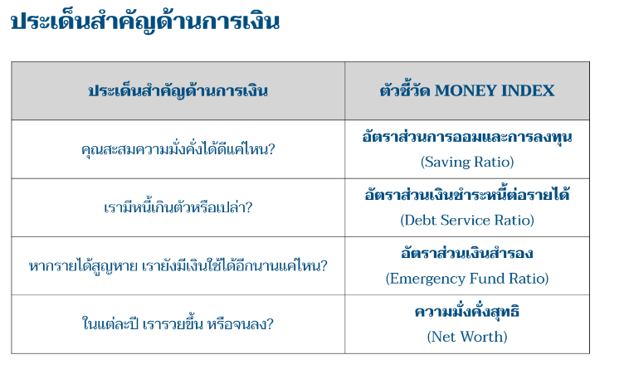

Figure 2.2 Ratio of Money Index

**2.2.1 Saving Ratio**

It is a ratio that indicates a person's ability to accumulate money each month, which reflects their readiness to take risks and the opportunity to become wealthy in the future, which in this ratio should be greater than or equal to 10%.

**2.2.2 Debt Service Ratio**

It is a ratio that indicates whether the debt burden incurred by a person is at an excessive level or exceeding the ability to pay installments, which should not exceed 50% of the debt to income (in case of home and car debt), and there should be no proportion of consumption debt to income exceeding 15%.

**2.2.3 Emergency Fund Ratio**

It is a ratio that tells of the ability to take risks in case of decrease or loss, how many months can you still spend on a normal daily basis if income is lost. For the reserve ratio, it should be more than or as much as 6. up to 12 (months)

**2.2.4 Net Worth**

It is a measure of the net asset volume, how much debt-free assets we have. Over the course of the period of earning a living income. What's more between assets and liabilities, preferably with a positive wealth status(+).

* 1. **Six Jars Saving Method**

6 JARS was invented by T Harv Eker, a global investment finance speaker and thinker. Owner of the book Secrets of the Millionaire Mind. The main principle of SIX JARS is to divide all monthly income into 6 parts, drop them into jars or jars. Each section is kept for different purposes.

The six jar method is a money management technique that will help you keep track of your budget.

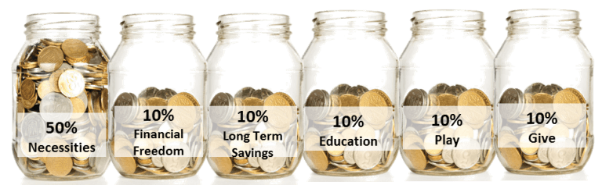

Figure 2.3 Six Jars saving technique

The savings principle of 6 Jars is to divide the money received each month into 6 jars according to various purposes.

**First Jar Daily Expenditure Necessities Accounts (NEC – 50%)**

The first dozen is the 'essential dozen'. To determine which part of the cost we're going to pick up from these dozens, judge by "if not, it's definitely hard," such as electricity, food, or electricity bills, not paying for it, lying sweaty, or, some might say, cosmetics are necessary. This is for some people, and each necessity is not the same.

**Two jars reward themselves Play Account (PLY- 10%).**

T Harv Eker believes that to be financially independent, your soul must be happy. The whole purpose of this story is to create happiness for yourself. Use a play account for everything your heart desires, but don't use this account for anything other than fun.

**Three-stakes Financial Freedom Account (FFA – 10%)**

This jar is your ticket to financial freedom that will eventually make you rich. The money you put into this jar is only used for investment and passive income. You will not be allowed to spend this amount of money. The only time you are allowed to spend this money is when you are financially independent. You are financially independent when you make the annual income you need without work, and even then you are only allowed to use your returns.

**Jar Four Education Education Account (EDU – 10%)**

This jar is to sharpen your saw. Successful people all have in common that they sharpen their saw (their brain). Investing in yourself is the best value. Because this money will increase skills. Developing various knowledge, which the younger children may collect this amount to apply for a baking lesson. Learn to sing, learn to dance, etc. We will collect this amount for 10% of the total income.

**Five Long-Term Saving For Spending Account (LTS – 10%)**

This money is meant to fill your dreams, and some people who want to have their own small businesses, such as coffee shops, tree shops, can rely on this money. Without borrowing anyone in debt, which we'll share in this pitcher, it's 10% of the total revenue.

**Six jars of money for sharing Give Account (GIV- 10%)**

The money in this jar is for **“charity”**. Use the money to do some good. Send it to a charity organisation you respect or buy some food with it and cook the food for the homeless. This is up to you. T. Harv Eker believes that by giving away money, the universe will reward you by giving you back more. I believe, however, that as long as you are a charity yourself, that you can use this 5% on your own family if you have poverty inside your circle.

* 1. **Money 101 : เริ่มต้นนับหนึ่งสู่ชีวิตการเงินอุดมสุข**

This book will be the first door for anyone interested in finance. and want to start taking control of their own financial future. The content of the book focuses on covering the main points of the story. "Personal finance" and give the main idea simple principles so readers can get started as soon as they finish each chapter. Rather than delving into complex details.

* + - * **Financial plan with 3 Baskets Saving**

1. **Emergency Basket**

This basket is a reserve in case of unforeseen events that may affect our finances, such as unemployment, wages, illness, or sudden need for money.

1. **Retirement Basket**

This basket is a source of money for retirement from work. Emphasis is placed on accumulating and investing in financial instruments. Use a simple and uncomplicated investment method.

1. **Money Freedom Basket**

This basket is a source of money to invest in assets that generate cash flow to generate wealth quickly. You can avoid worrying about your finances before you retire from work.

* 1. **Overview of competitors**

There are many existing web applications that aim to first jobbers. Four outstanding representatives are chosen to analyze their system, features, UI Design, teaching model, business model, and their successful stories.

* + 1. **บริหารการเงินส่วนบุคคล by RARUS-SOFT, OOO**

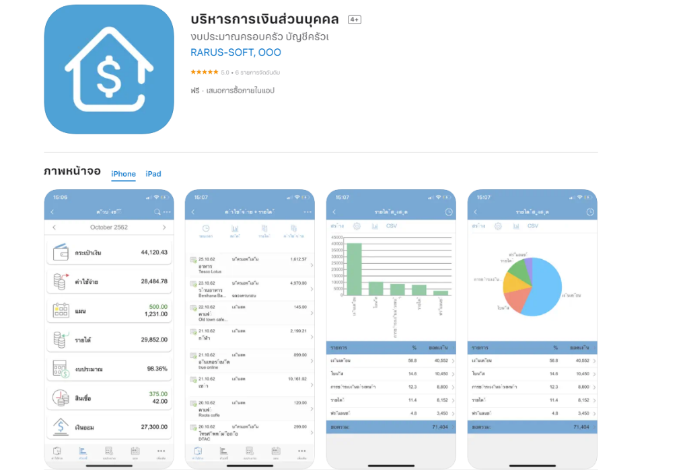

Figure 2.4 Personal financial advisor application

personal finance management program It is a tool used for accounting, analysis, control of personal money. and efficient financial planning The program has four sub-systems: the income-expense system, the asset-liability system, the financial planning system. and savings system The user interface is the one that is easy to use. Both advanced and novice users can easily perform financial analysis and accounting. without having to connect to the Internet.

* + 1. **Planme**

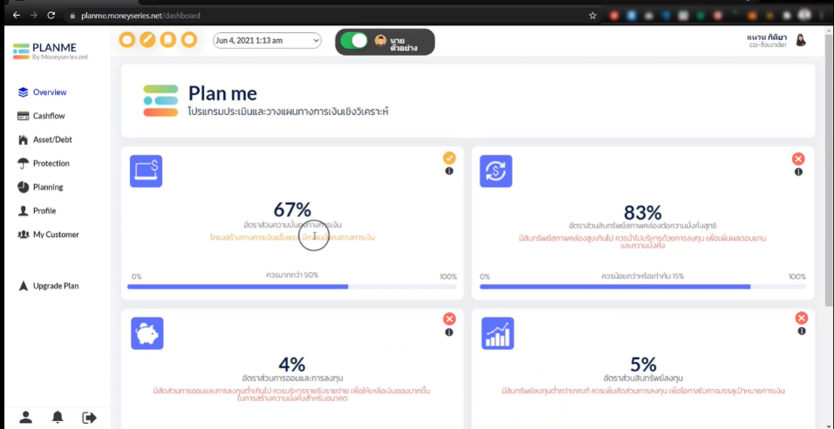

Figure 2.5 Planme program interface

This program can tell all user inputs. whether it is a matter of the cash flow statement

Planme is a personal financial planning program. for career planners And people who want to plan their own and your clients' finances in a simple but detailed and practical way.

* + 1. **Lumpsum**

Figure 2.6 Lumpsum application interface

“Lumpsum” Application is a financial planning assistant. Able to plan a complete financial plan, easy to use, suitable for everyone Help record income - expenses. Planning for retirement, tax planning, and investing in funds and life insurance.

* 1. **The competitor analysis**

There are many existing web applications. Three outstanding representatives are chosen to analyze their system, features, UI Design, teaching model, business model, and their successful stories.

|  |  |  |  |
| --- | --- | --- | --- |
| Features | บริหารการเงินส่วนบุคคล by RARUS-SOFT, OOO | Planme | Lumpsum |
| 1. Income-Expense | √ | √ | √ |
| 1. Calculation program | √ | √ | √ |
| 1. Set goal | √ | √ | √ |
| 1. Saving | √ | √ | √ |
| 1. Risk assessment | √ | √ | √ |
| 1. Suggestions and Consulting |  | √ |  |

Table 2.1 Competitor analysis features

All platforms have Income-Expense, Calculation, set goal, Saving money, and Risk assessment . Only Planme has the suggestionfeature . While PFA has all mentioned features, it also provides tracking the level of financial status and the Saving

* 1. **Overview of tool and technologies used**
     1. **Line LIFF**

LINE Front-end Framework (LIFF) is a platform for web apps provided by LINE. The web apps running on this platform are called LIFF apps. LIFF apps can get data from the LINE Platform such as the LINE user ID.



Figure 2.7 Line LIFF

* + 1. **Line Chatbot**

LINE chatbot is an automated software, programmed to chat with users through the LINE messaging app. LINE chatbots are capable of responding to customer queries, ask relevant questions, provide product suggestions and even hand over conversations to an agent when required.

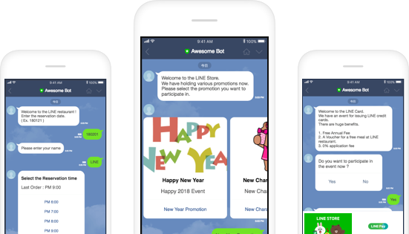

Figure 2.8 Line ChatBot

* 1. **Terminologies**
* Money index
  + financial health indicators It makes it easier for you to set goals and plan your finances.
* Earning money
  + To earn money is to earn enough to support yourself.
* Spending money
  + Managing expenses is to manage expenses appropriately.
* Fixed Expenses
  + Fixed expenses are fixed expenses or expenditures that are encumbrance from debt obligations. such as rental taxes or home installments. Car installment payment, debt repayment, various credits, utilities, insurance premiums, parental or child support payments that must be sent on a monthly basis, etc.
* Variable Expenses
  + variable expense is an expenditure that can be managed Varies according to individual management each month, such as travel expenses, food expenses, personal expenses, etc.
* Bad Debt
  + Bad debt is debt that causes additional cost The more there are, the more.
* Good Debt
  + Rich Debt is debt that generates additional income is a form of borrowing money to invest. in cash-generating assets with positive net cash flow.
* OPM
  + Other People Money is using other people's money. It will help your business grow rapidly. The most obvious example is Using money from banks for business expansion
* OPR
  + Other People Resource is you trade your resources for someone else's resources.

CHAPTER 3

# Analysis and Design

This chapter shows and describes the system analysis and design of TappTact. This chapter comprises the system overview, system architecture, system flow, structure chart, database analysis and design, and interface design.

## System Overview

Financial Health Check is proposed as a smart business contact management and verification

system. TappTact consists of two parts which are TappTact for the mobile users and

TappTact for the business companies.

Financial Health Check for the mobile users can assist the users to manage the contacts. The mobile users can create the virtual business cards and exchange their contact information easily. After exchanging, the mobile users can give notes and hashtags to each card for searching. Moreover, the users can verify other users’ identity and their working status. In addition, the mobile users can track their card’s usage such as the amount of sent and received cards.

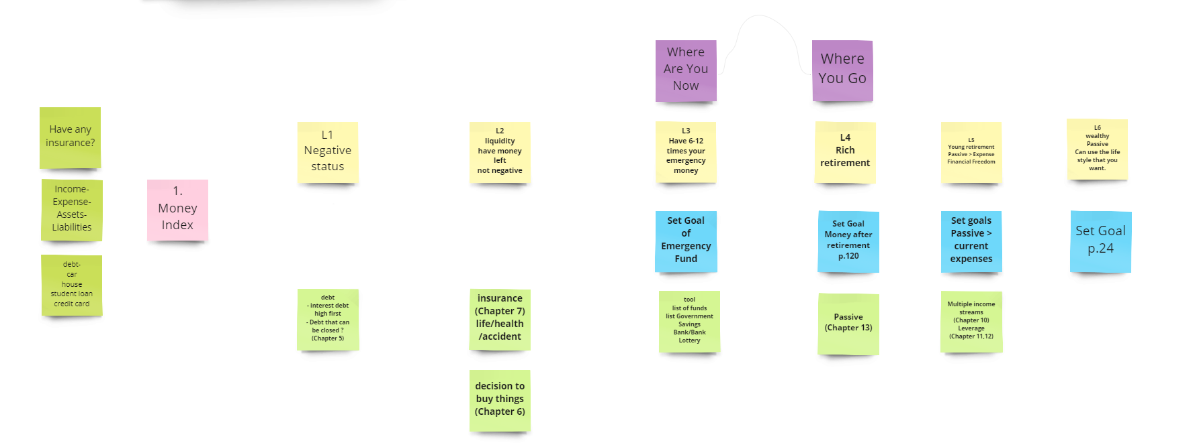

Figure 3.1 Overview of Personalized Financial Advisor System

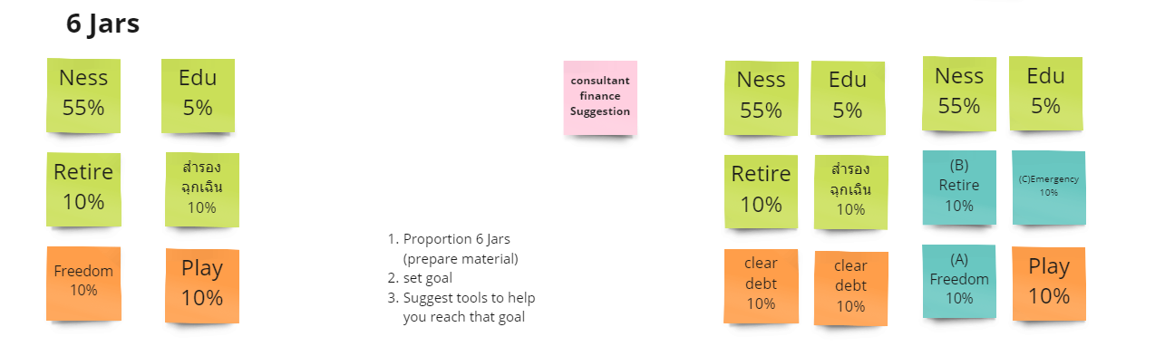

Figure 3.2 Overview of Personalized Financial Advisor System

Figure 3.3 Overview of Personalized Financial Advisor System

The Personalized Financial Advior System has three main parts: Grading system by Money Index, Level of financial status, and Suggestions and consult.

* + 1. **Grading system by Money index**

This step will give the user to input their own Personal Financial Statement to grading using money index that consists of Saving ratio, Debt service ratio, Emergency Fund Ratio, and Net worth. The output will show as saving, Expenses, and balance.

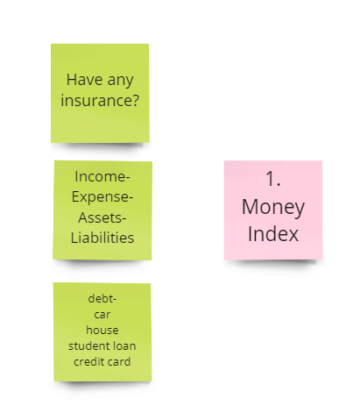

Figure 3.4 Input to Money Index

* + 1. **Level of financial status**

This part will show where is the level of the user now after doing the grading system. And also, can look for where you will go to the next level as well. Consists of 6 Levels as follows:

**Level 1** - Negative financial position.

Sugguestion: debt interest debt high first Debt that can be closed.

**Level 2** – Liquidity There is no negative balance left.

Sugguestion: insurance, Life/ health/accident, Decision to buy things.

**Level 3** – Emergency saving greater than 6-12 months

Sugguestion: Set goal of Emergency Fund

**Level 4** – Rich Retirement

Sugguestion: tool- list of funds, list Government, Savings Bank, Bank Lottery.

**Level 5** – Young Retirement

Sugguestion: Set goal Money Rich retirement

**Level6** – Wealth you! Congratulations

Sugguestion: Set goal young retirement

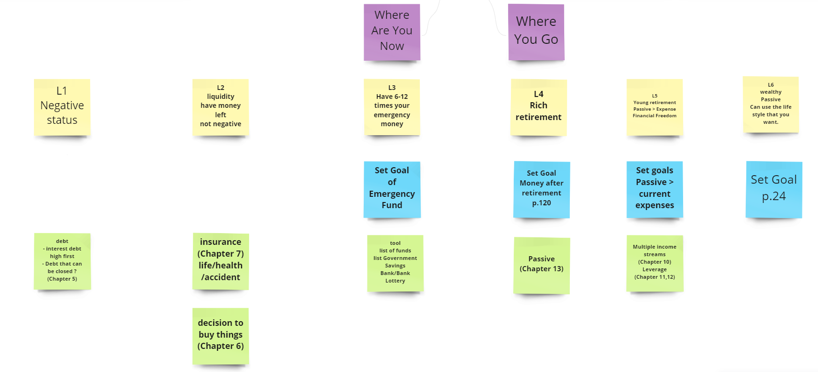  
Figure 3.5 Sugguestions of each level

* + 1. **9 Jars saving money management technique**

This section deals with a savings and spending technique known as '8 Jars', which has been adapted from the '6 Jars' savings to be more precise. Taking into account future finances and can be flexible or adjust according to the financial situation that arises.

Figure 3.6 9 Jars money management

CHAPTER 4

# Implementation

This chapter is mainly focused on the solution design which includes the overview of the personal financial advisor system, grading by Money Index, Level of personal financial, suggestions and Saving money management technique, and future of work.

* Implementation
* Hardware and software requirements
* Requirements for developers
* Requirements for users
* Implementation of the Basic Financial Health check system
* Creating of the Basic Financial Health check system
* Deploying of the Basic Financial Health check system
* Interacting to the Basic Financial Health check system
* Implementation of the Grading by Money Index system

This chapter outlines the hardware and software requirements for the developers and the users as well as explains the implementation guides and techiques used in Financial Health check.

4.1 Hardware and Software Requirements

4.1.1 Hardware Requirements for Developers

* HP Pavilion x360 Convertible 14-dh1xxx
* Processor Intel(R) Core(TM) i7-10510U CPU @1.80GHz, 2304 Mhz, 4 Core(s), 8 Logical Processor(s)

4.1.2 Database Management System (DBMS)

* MySQL

4.1.3 Software

* Visual Studio 2023
* Node.js

4.2 Implementation Guide and Techniques

4.2.1 Creating the Line Official

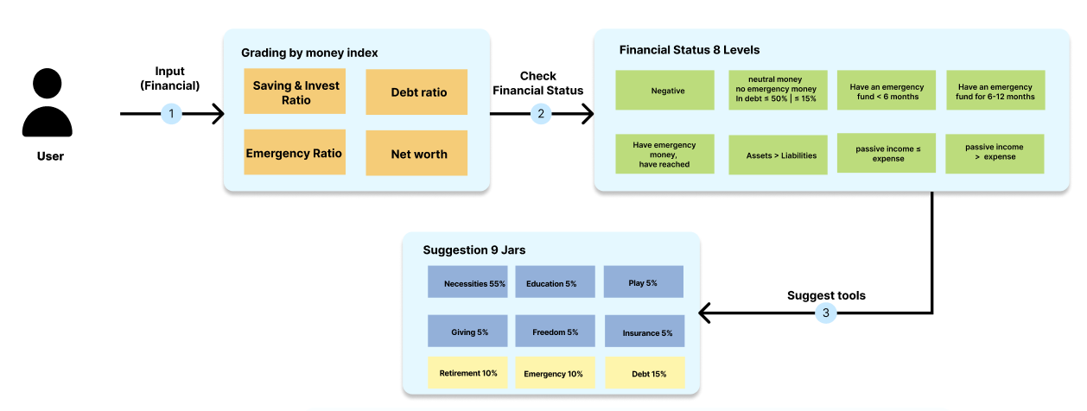

CHAPTER 5

# Testing and Evaluation

This chapter cromprises of three section which are unit tests, system integration test, and experiment results.

* 1. **Unit Tests**
     1. **Test Performed on Line LIFF**
     2. **Test Performed on Web view**
  2. **System Integration Test**

This activity is performed after the system is completely integrated. The purpose of this testing is to check whether the system can operate correctly according to the required functions or not.

* Use case 1: User Sign up and input their personal profile.
* Use case 2: User Evaluation
  1. **User Testing and Evaluation Result**

The purpose of the user testing is to obtain feedback from target users in order to improve the quality of TappTact by performing an individual interview with the participants to test features, usability, and the overall feeling of the application. There are five participants joining the session as follows:

***What do you think about the Financial Health Check system?***

***How can the Financial Health Check system solve your existing problems?***

***What do you like the most about the Financial Health Check system?***

CHAPTER 6

# Conclusion

This is the last chapter of this document. This chapter presents benefits, benefits to project developers, benefits to users, problems and limitations, and future work of this project.

* 1. **Benefit**
     1. **Benefits to the project Developers**
        + Improve the expertise and skills in the area of software analysis, software

design and development

* + - * Utilize the knowledge that has been learned from academic courses
      * Improve Financial literacy skill skills
      * Enhance programming skills with the new programming language such as Solidity
      * Experience from participating in the Thailand National Software Contest
    1. **Benefits to Mobile Users**
       - Improve the Financial management skill
  1. **Problems and Limitations**
* Implementation and Coding skill: One potential problem and limitation in the context of implementation and coding skills is the lack of expertise or experience of the programmer. If the programmer lacks the necessary skills to write efficient and effective code, it may result in the development of a system that does not perform as expected or may lead to security vulnerabilities or software bugs.

nother issue is the potential for errors and bugs in the code that may not be immediately apparent, and this can lead to the system malfunctioning or not functioning at all. In addition, changes or updates to the codebase can sometimes introduce new issues or break existing functionality, making it difficult to maintain and update the system over time.

* 1. **Future Work**
* Suggestion
* To add more the suggested feature
* Calculation
* To suggest the basic calculation
* 9 Jar management
* To have more features and conditions
* Notification
* Notice to have saving money by using 9 Jars.

# References

|  |  |
| --- | --- |
| [1] | J. Mespan, Money 101: เริ่มต้นนับหนึ่งสู่ชีวิตการเงินอุดมสุข, Bangkok: 2019, 2019. |
| [2] | T. Warit, "มารู้จักกับ LIFF — สิ่งที่จะมาเติมเต็มในการทำ Chat Bot กัน!," LINE Developers Thailand, 6 June 2018. [Online]. Available: https://medium.com/linedevth/introduction-to-liff-7d708e2f42ec. [Accessed 28 November 2022]. |
| [3] | B. o. Thailand, "รายงานผลการสำรวจทักษะทางการเงินของไทย," Bank of Thailand, Bangkok, 2563. |
| [4] | J. Mespan, "ตรวจสุขภาพทางการเงินด้วย 4 ดัชนีชี้วัดที่ช่วยให้การวางแผนทางการเงินเป็นเรื่องง่าย," GQ Thailand, 8 October 2563. [Online]. Available: https://www.gqthailand.com/lifestyle/article/financial-health-check. [Accessed 28 November 2022]. |
| [5] | Planme, "แนะนำโปรแกรม Planme," Moneyseries, 12 June 2021. [Online]. Available: https://planme.moneyseries.net/. [Accessed 28 November 2022]. |
| [6] | e. investmnet, "Lumpsum," efin investment fit you, 31 October 2022. [Online]. Available: https://www.lumpsum.in.th/MyApp. [Accessed 28 November 2022]. |
| [7] | R.-S. OOO, "บริหารการเงินส่วนบุคคล," RARUS-SOFT, OOO, 2017. [Online]. [Accessed 28 November 2022]. |

# Appendix

User manual

1. Money101 by The Money Coach (Jakkapong Mespan)

This book serves as an introductory gateway for those interested in personal finance and looking to take control of their financial future. The content focuses on covering essential topics in "personal finance" and provides simple principles and practices for readers to begin implementing immediately after finishing each chapter. It goes beyond delving into complex details.

1. Financial Health check system
2. Sign in
3. Input your personal profile
4. Dashboard
5. Grading page
6. Suggestion page
7. 9 Jars money management

BIOGRAPHIES

|  |  |
| --- | --- |
| NAME | Mr. Chatchai Kraisornsin |
| INSTITUTIONS ATTENDED | Rajavinit Mathayom, 2018:  High School Diploma  Mahidol University, 2019 :  Bachelor of Science (ICT) |
|  |  |
|  |  |
|  |  |
|  |  |
|  |  |
|  |  |